Github link: <https://github.com/Yessenchik/full_website>



<div id="main-slider" class="flexslider">

<ul class="slides">

<li>

<img src="img/slides/1.jpg" alt="" />

<div class="flex-caption">

<div class="item_introtext">

<strong>Online Education</strong>

<p>The best educational template</p> </div>

</div>

</li>

<li>

<img src="img/slides/2.jpg" alt="" />

<div class="flex-caption">

<div class="item_introtext">

<strong>School Education</strong>

<p>Get all courses with on-line content</p> </div>

</div>

</li>

<li>

<img src="img/slides/3.jpg" alt="" />

<div class="flex-caption">

<div class="item_introtext">

<strong>Collage Education</strong>

<p>Awesome Template get it know</p> </div>

</div>

</li>

</ul>

</div>

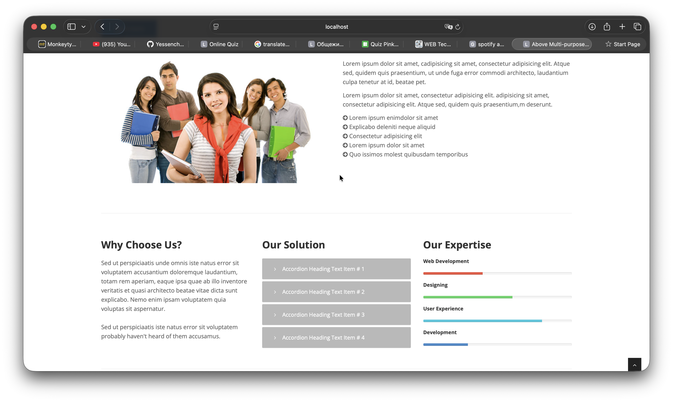

<div class="col-md-4">

<div class="block-heading-two">

<h3><span>Our Expertise</span></h3>

</div>

<h6>Web Development</h6>

<div class="progress pb-sm">

<!-- White color (progress-bar-white) -->

<div class="progress-bar progress-bar-red" role="progressbar" aria-valuenow="40" aria-valuemin="0" aria-valuemax="100" style="width: 40%">

<span class="sr-only">40% Complete (success)</span>

</div>

</div>

<h6>Designing</h6>

<div class="progress pb-sm">

<div class="progress-bar progress-bar-green" role="progressbar" aria-valuenow="60" aria-valuemin="0" aria-valuemax="100" style="width: 60%">

<span class="sr-only">40% Complete (success)</span>

</div>

</div>

<h6>User Experience</h6>

<div class="progress pb-sm">

<div class="progress-bar progress-bar-lblue" role="progressbar" aria-valuenow="80" aria-valuemin="0" aria-valuemax="100" style="width: 80%">

<span class="sr-only">40% Complete (success)</span>

</div>

</div>

<h6>Development</h6>

<div class="progress pb-sm">

<div class="progress-bar progress-bar-yellow" role="progressbar" aria-valuenow="30" aria-valuemin="0" aria-valuemax="100" style="width: 30%">

<span class="sr-only">40% Complete (success)</span>

</div>

</div>

</div>

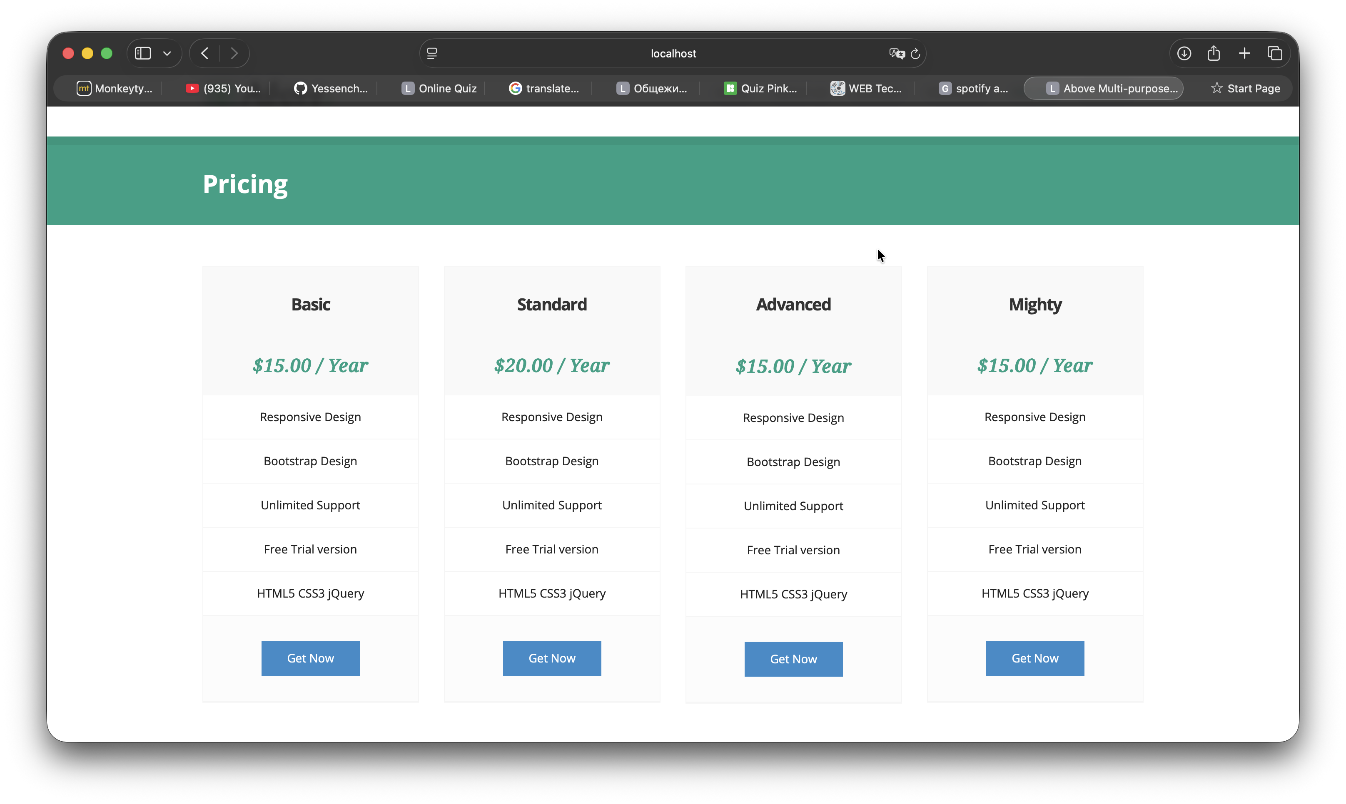

<div class="pricing-heading">

<h3><strong>Standard</strong></h3>

</div>

<div class="pricing-terms">

<h6>&#36;20.00 / Year</h6>

</div>

<div class="pricing-container">

<ul>

<li><i class="icon-ok"></i> Responsive Design</li>

<li><i class="icon-ok"></i> Bootstrap Design</li>

<li><i class="icon-ok"></i> Unlimited Support</li>

<li><i class="icon-ok"></i> Free Trial version</li>

<li><i class="icon-ok"></i> HTML5 CSS3 jQuery</li>

</ul>

</div>

<div class="pricing-action">

<a href="#" class="btn btn-medium btn-theme"><i class="icon-bolt"></i> Get Now</a>

</div>

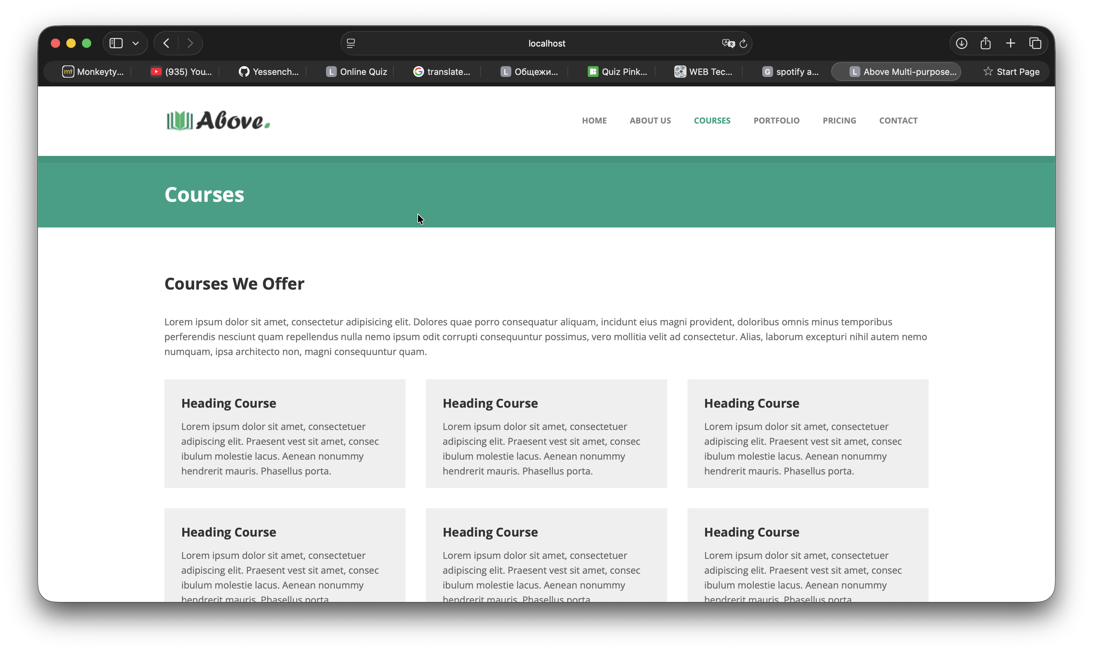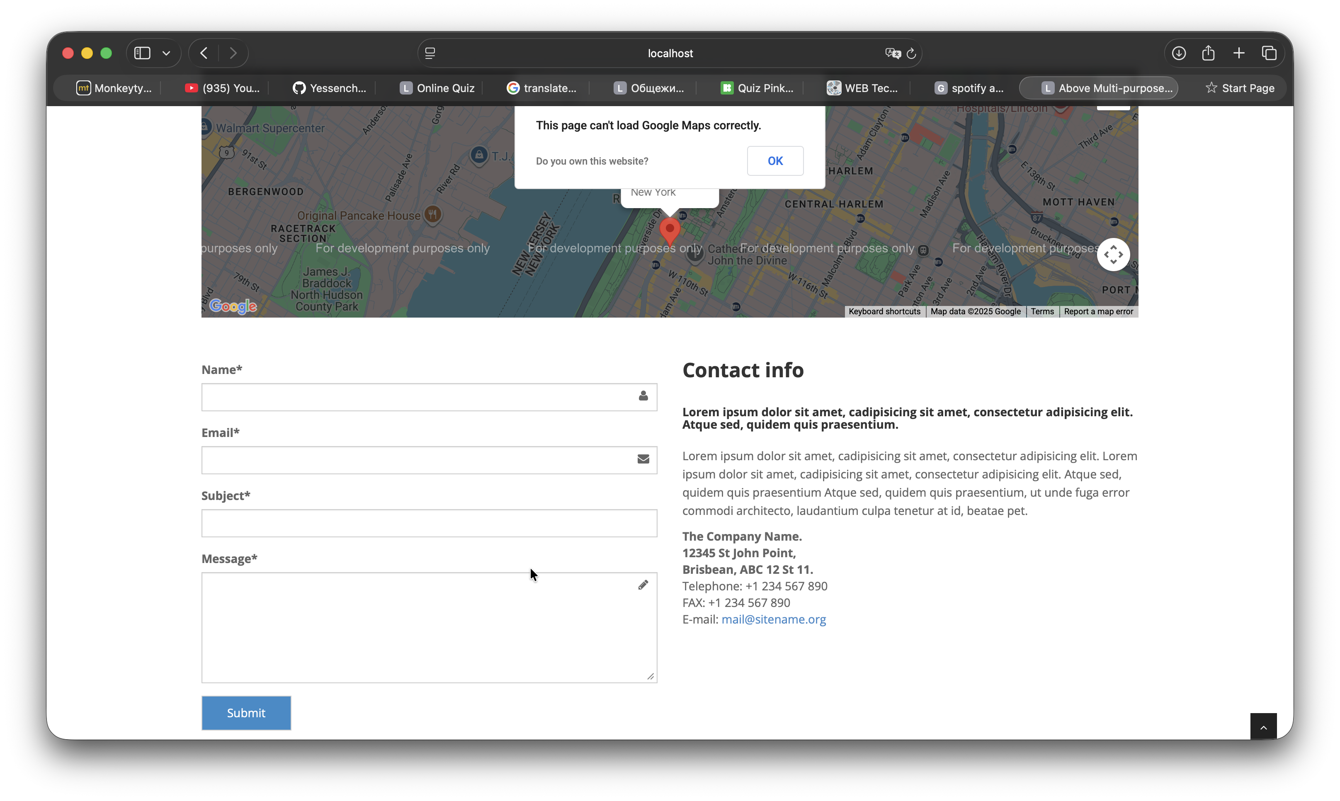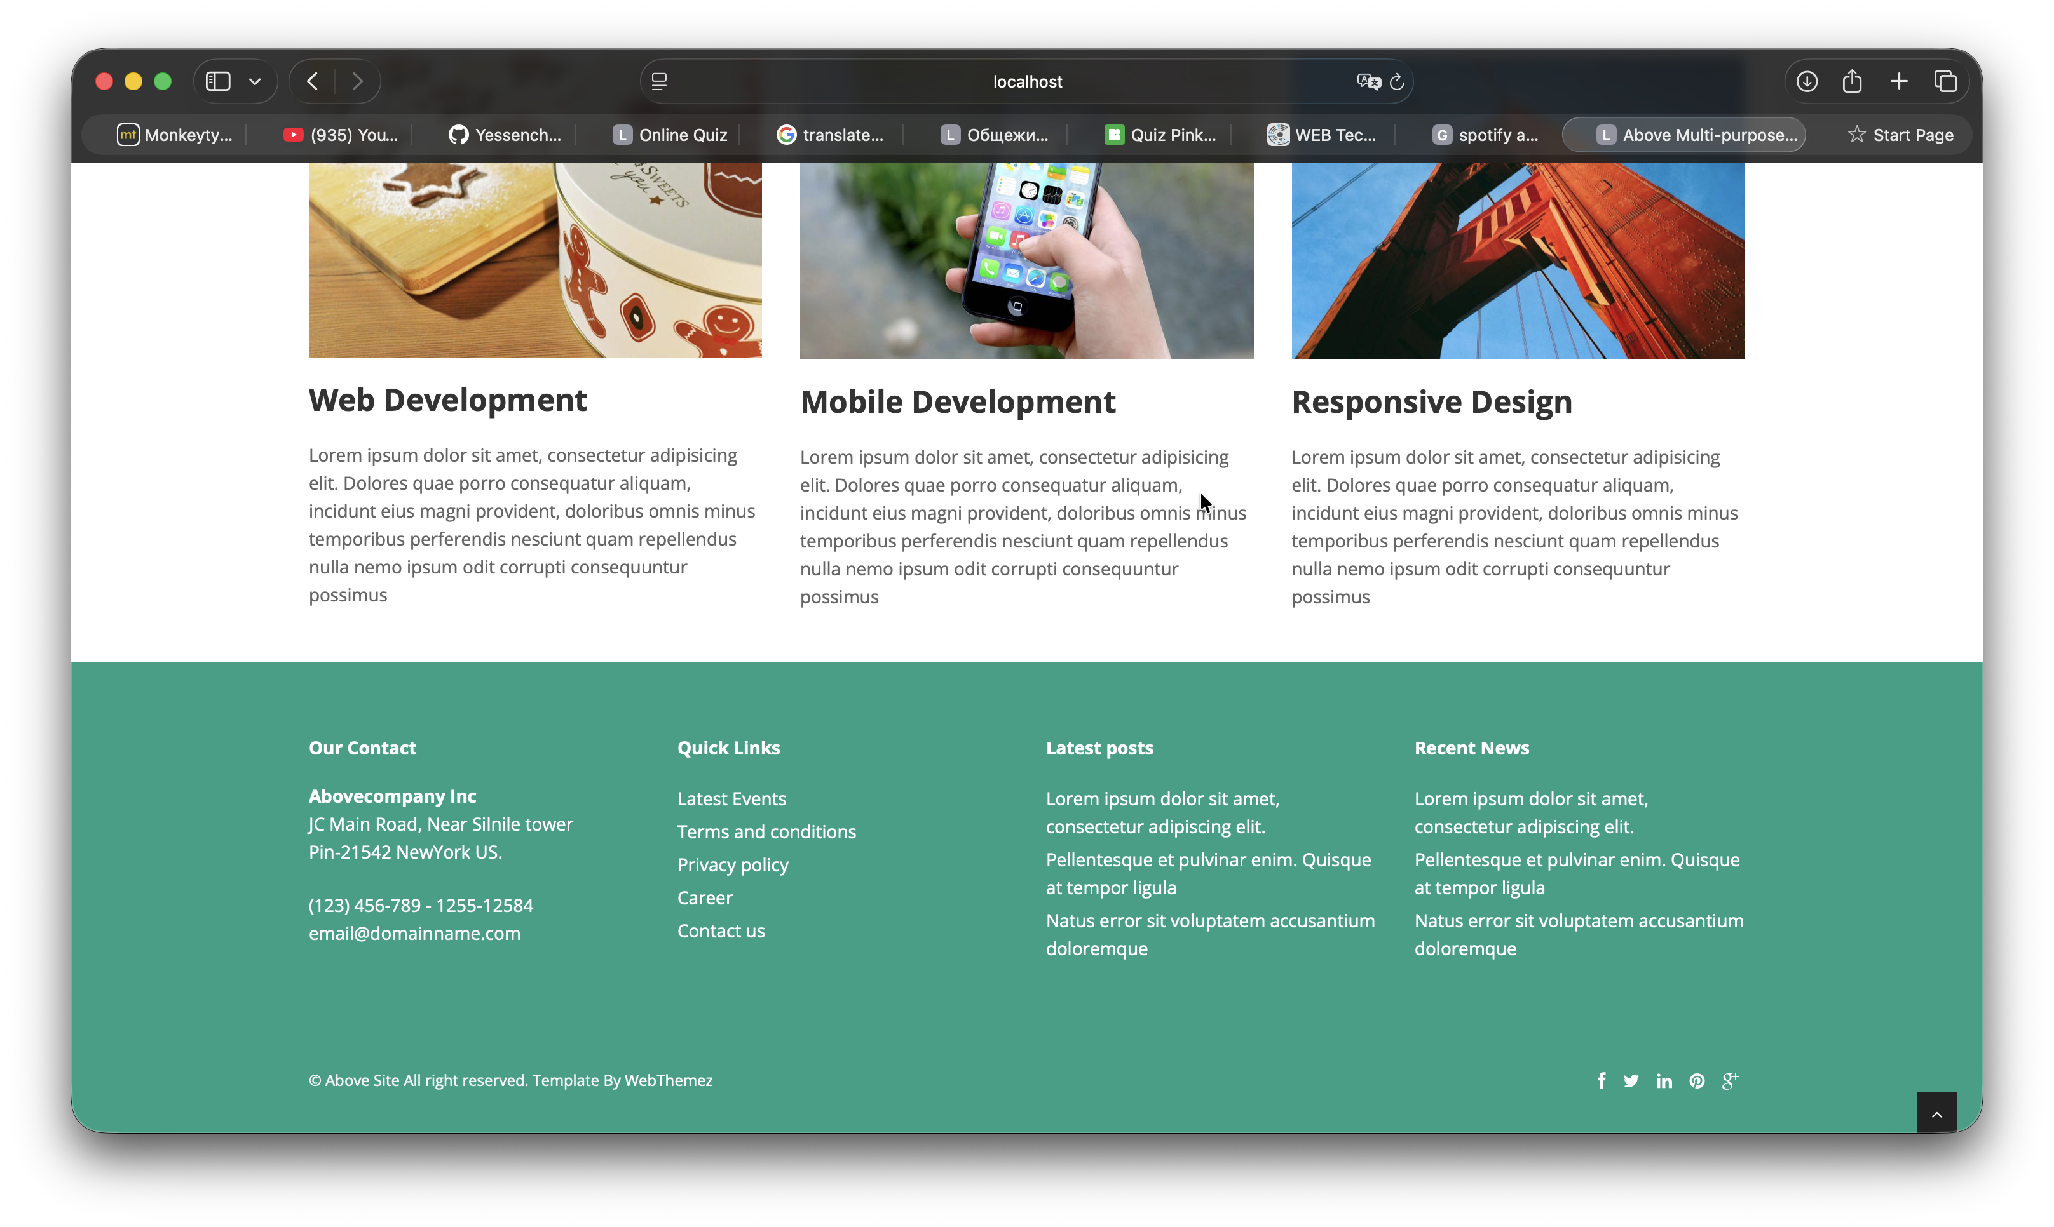

Summary  
  
I develop more than 5 pages  
Use only frontend things(html, css, bootstrap, javascript)